

**Subject Teacher**

**Muhammad Owais Rehmani**

* + - **Name: Firza Ghori**
    - **Batch: 23**
    - **Roll No: 036**
    - **Subject: Programming Fundamental**
    - **Department: Artificial Intelligence**
    - **Assignment : while loop for loop &**

**Control flow**

**Submitted date: 26 - 11-2023**

**Exercise 1:**

* **Write a program using a for loop to print the numbers from 1 to 10.**

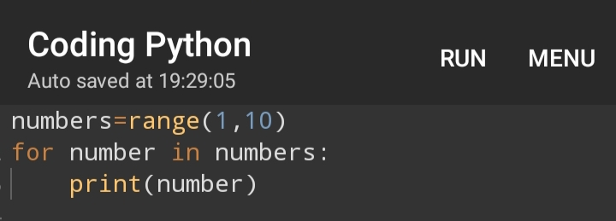**Output**

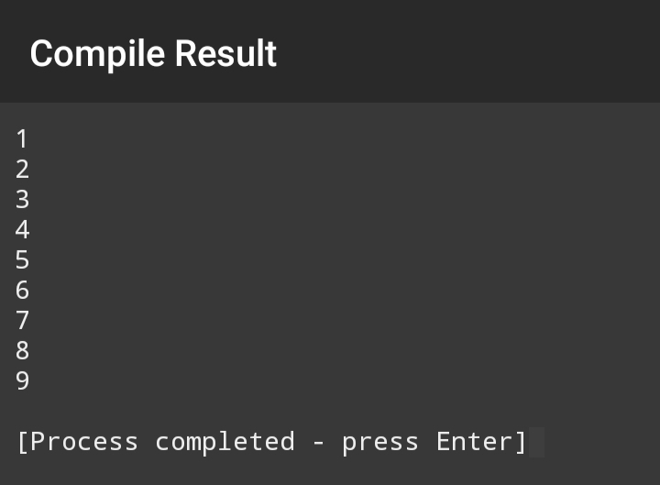

**Exercise 2:**

* **Create a program that uses a for loop to print the multiplication table of the user-inputted number.**

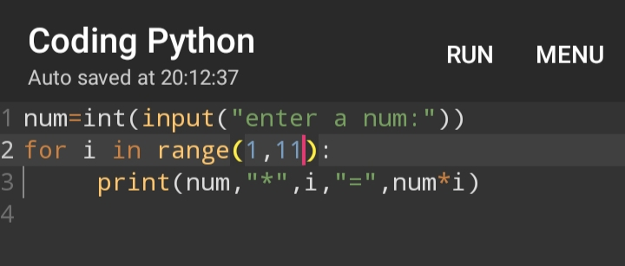

**Output**

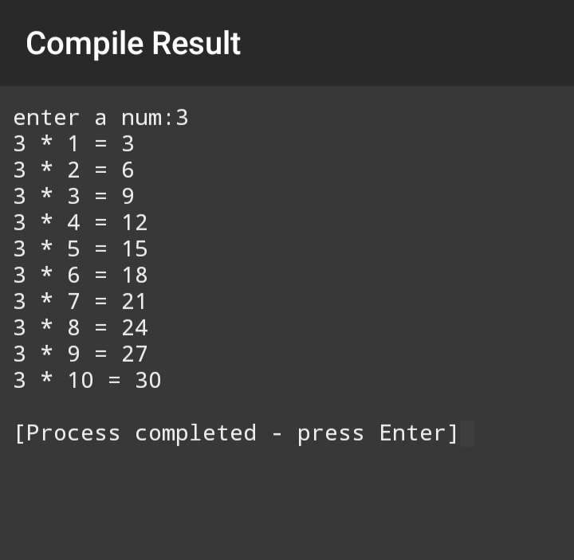

**EXERCISE 3:**

* **Write a program that uses a while loop to find the sum of natural numbers up to a given number entered by the user.  
  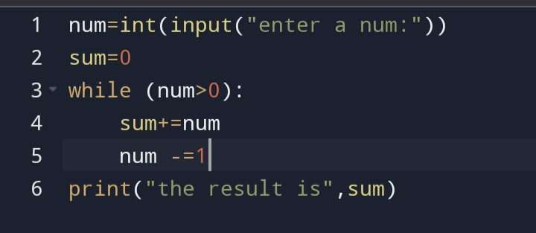**

**Output**

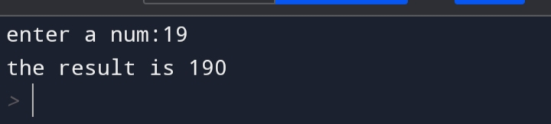

**Exercise 4:**

* **Create a program that uses a for loop to iterate through a list of name and print each name.**

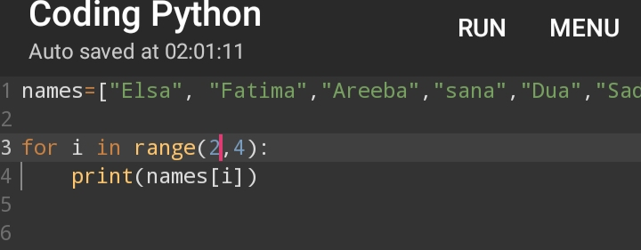

**Output**

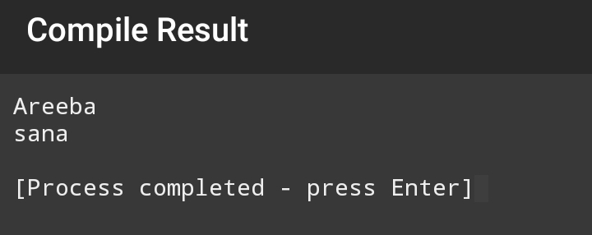

**Exercise 5:**

* **Write a program using a while loop to find factorial of a user inputted number.**

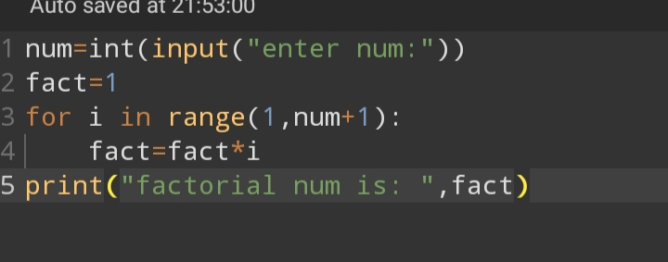

**Output**

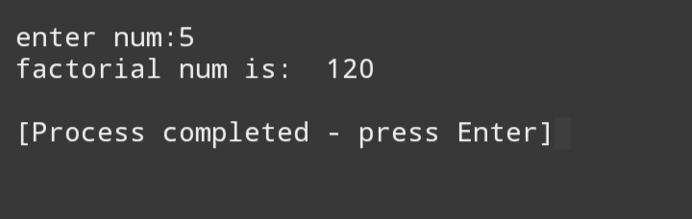

**Exercise 6:**

* **Create a program using a for loop to print the fabonacci series up to specified number of term entered by the user.**

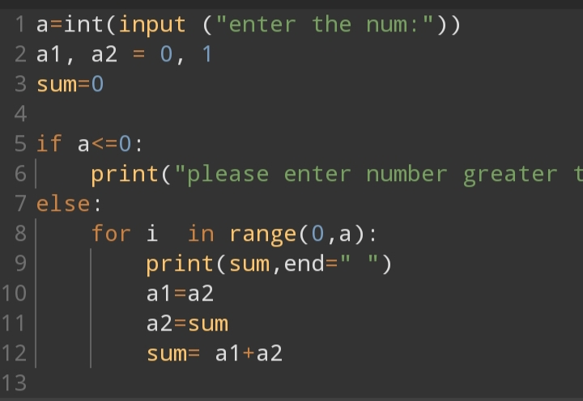

**Output**

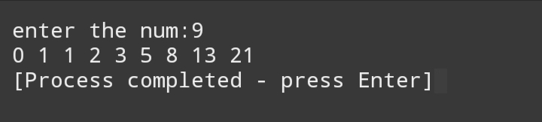

**Exercise 7:**

* **Write a program using a while loop to reverse a number entered by a user.  
    
  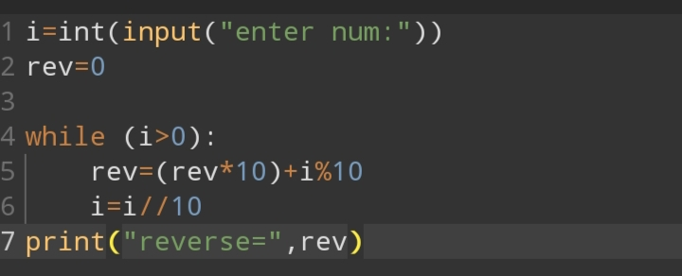**

**Output**

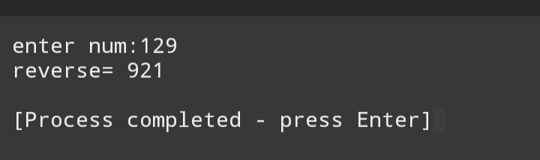

**Exercise 8:**

* **Create a program that use a for loop to iterate through a string and count the number of vowel.   
    
  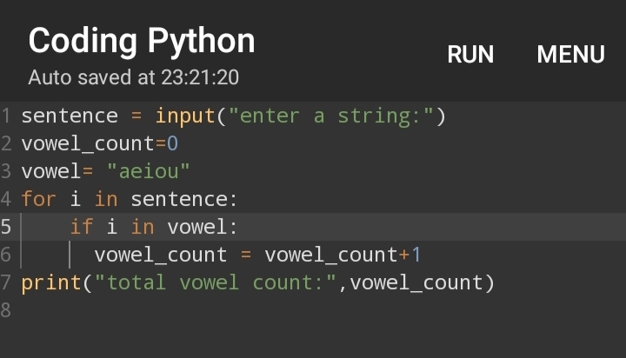**

**Output**

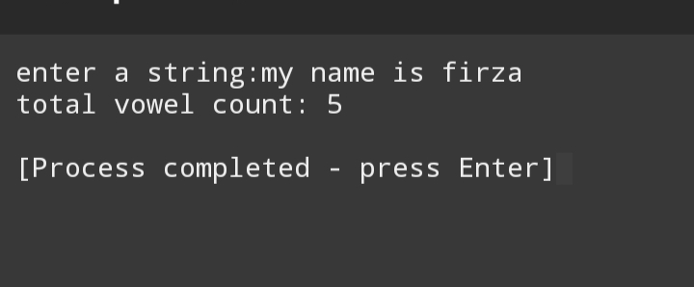

**Exercise 9:**

* **Write a program using a while loop to check if a user inputted number is a palindrome.  
    
  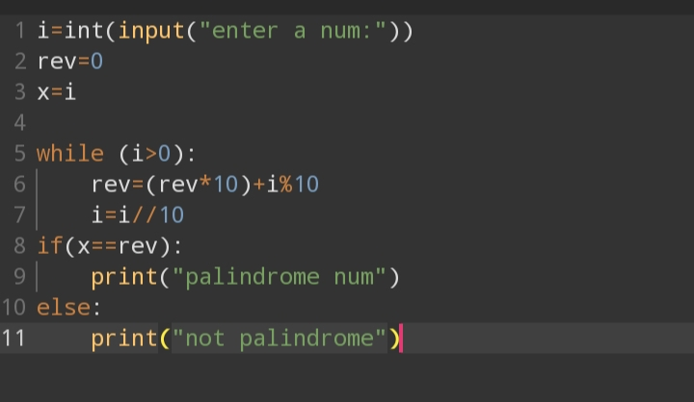**

**Output**

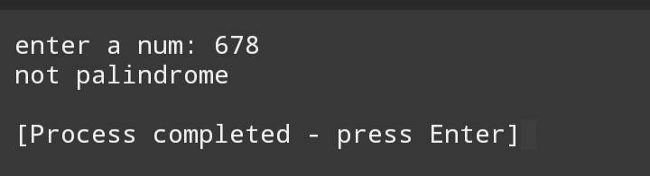

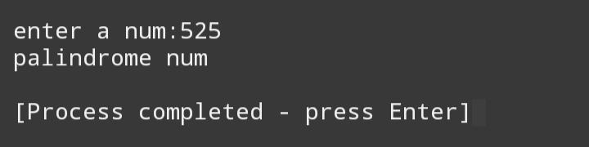

**Exercise 10:**

* **Create a program using a for loop to calculate and print the sum of the squares of the numbers from 1 to 5**

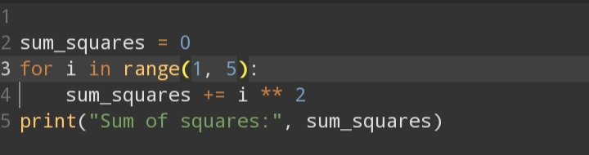

**Output**

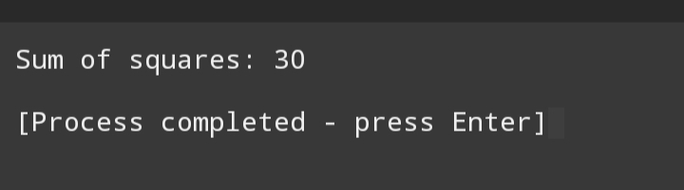

**Assignment#2**

**Control and flow**

**Exercise 1:**

* **Write a python program that takes a number as input and print “even” if it’s even and “odd” if it’s odd**

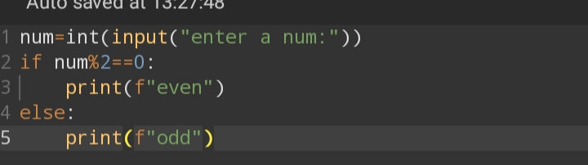

**Output**

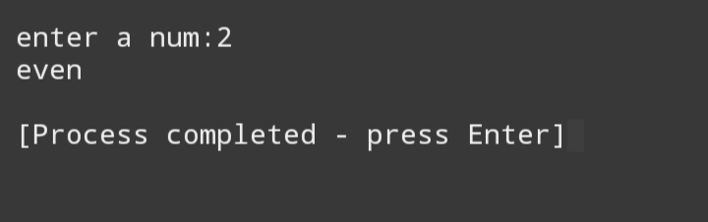

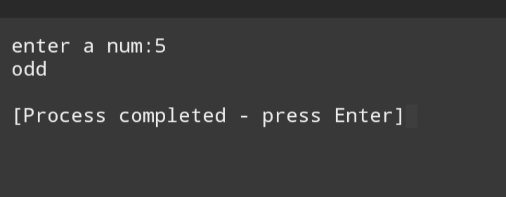

**Exercise 2:**

* **Create a program that checks if a user inputted year leap year. Print result accordingly.**

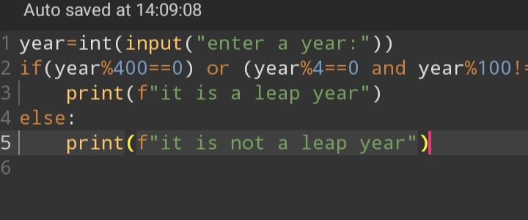

**Output**

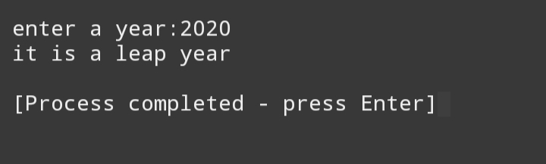

**Exercise** 3:

* **Write a program that prompts the user to enter their age. If the age is 18 or above, print “you are an adult,” and otherwise print “you are a mirror”.**

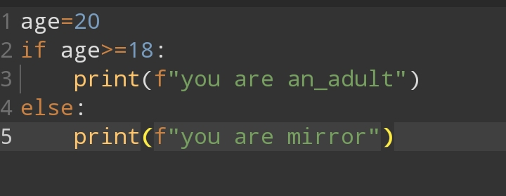

**Output**

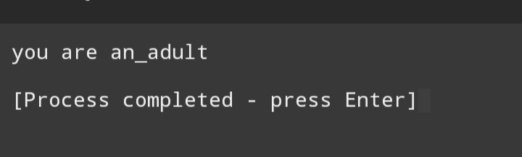

**Exercise 4:**

* **Create a simple login system. Ask the user to enter their username and password. If the username is “admin” and password “12345”, print “login successful,” otherwise print “login failed”**

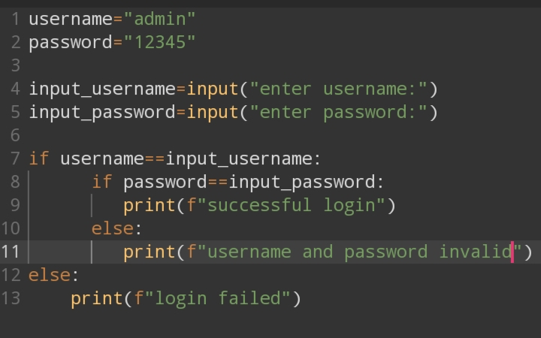

**Output**

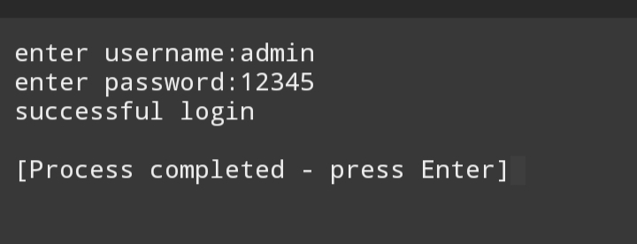

**Exercise 5:**

* **Write a program that determine if a given number is positive, negative, or zero. Print the result accordingly   
    
  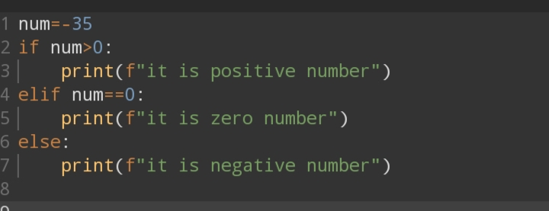**

**Output**

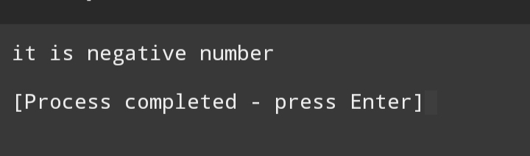

**Exercise 6:**

* **Ask the user to enter three number. Find and print the maximum of three number.**

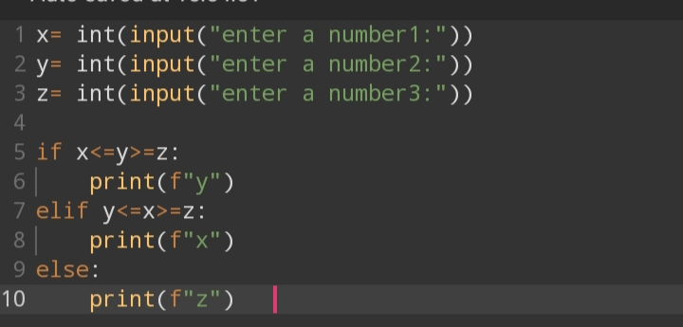

**Output**

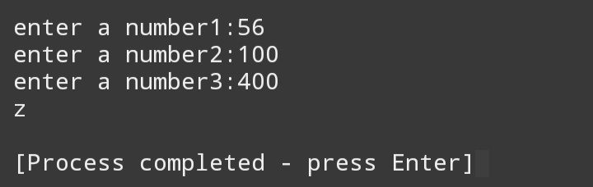

**Exercise 7:**

* **Create a grading systems, take a numeric score as input and print corresponding grade (A,B,C,D,F)**

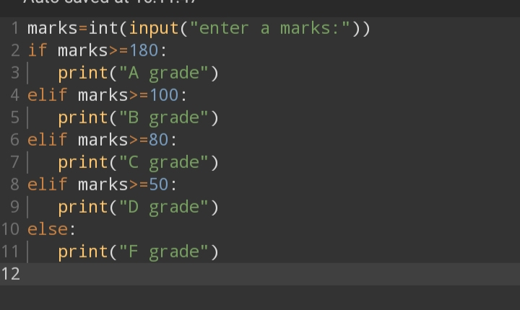

**Output**

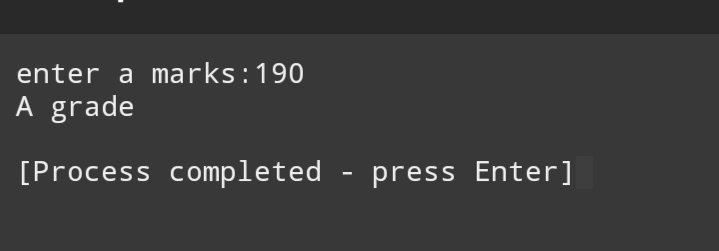

**Exercise 8:**

* **Write a program to check user _ inputted number is a prime number or not. Print the result.**

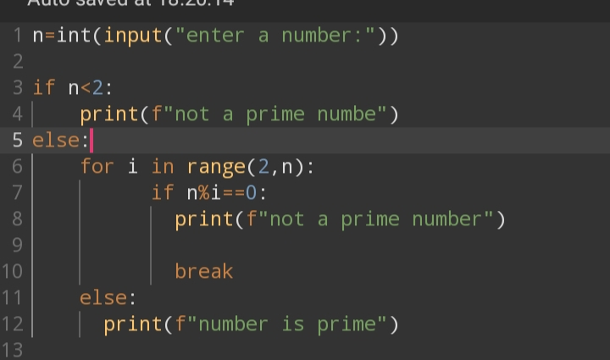

**Output**

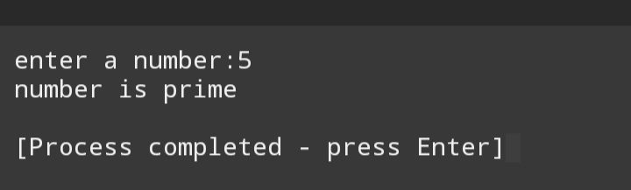

**EXERCISE 9:**

* **Create a program that checks if a user _ inputted year is a leap year. If it is , print “leap year, “otherwise print “Not a leap year”.**

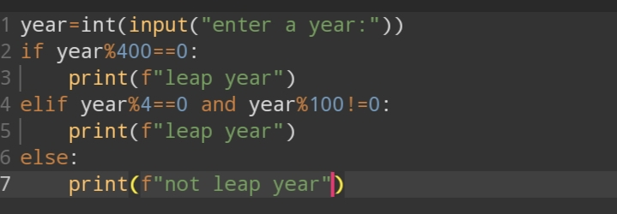

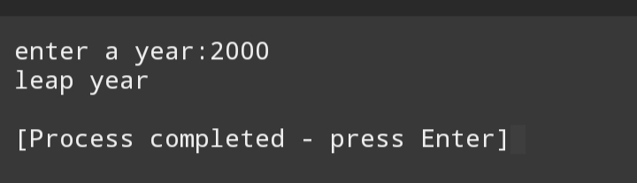**Output**

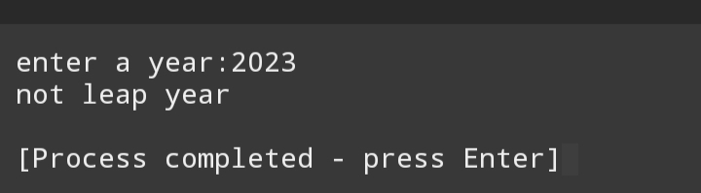

**Exercise 10:**

* **Prompt the user to enter two number. Print the large number or a message saying they are equal.**

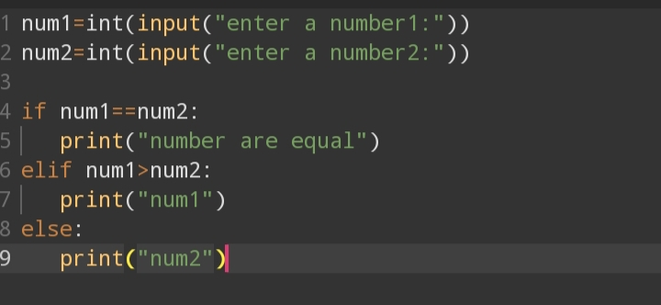

**Output**

